***Lean & Green: Can Lean Six Sigma Save the Planet?***

*A Case Study in Seaweed Production*

Justyna Skiba S00274779

Published on 06.10.24

In the face of a rapidly changing climate and the urgent need to meet Paris Agreement goals, organizations are under immense pressure to redefine and manage their sustainability goals. The vast concept of sustainability is becoming increasingly intertwined with environmental, economic, and social factors. This interdisciplinary nature demands a diverse and equally interdisciplinary toolkit. *Can Lean Six Sigma, a methodology known for its focus on efficiency and waste reduction, be adapted to tackle sustainability objectives?* In this blog post, we'll delve into the potential of Lean Six Sigma to address the complex challenges of sustainability.

To answer this question let's focus on the case study of sourcing a seaweed driven polysaccharide called carrageenan. The company is a medium-scale agri-food producer based in Indonesia and its main product - carrageenan powder is used as an ingredient in food and cosmetic manufacturing. As production heavily relies on natural resources (seaweed) the organization's focus is on improving their sustainable manufacturing, reducing waste and negative environmental impact. (Utama, Abirfatin, 2023).

To address their sustainability goals, the manufacturer used **DMAIC** theLean Six Sigmaframework that stands for definition, measure, analysis, improve and control (Fig.1). It’s based on a systematic approach to identifying problems, measuring performance, analyzing causes, and continuous improvement (Utama, Abirfatin, 2023).

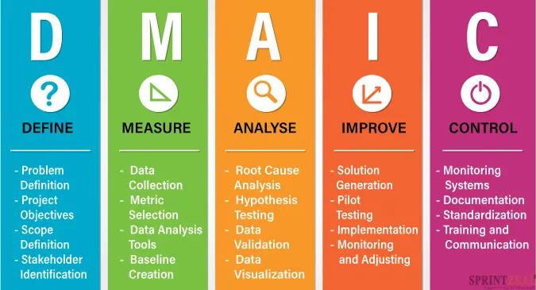

Fig.1. DIMAC process (Sushmith, 2023).

**Deﬁne -** **SIPOC and Sustainability: A Winning Combination**

In the define phase of DMAIC framework, the producer used **SIPOC** tool to map out the process that could drive the green initiatives. This helps to clarify the process's inputs, outputs, and the roles of suppliers and customers (Fig 2).

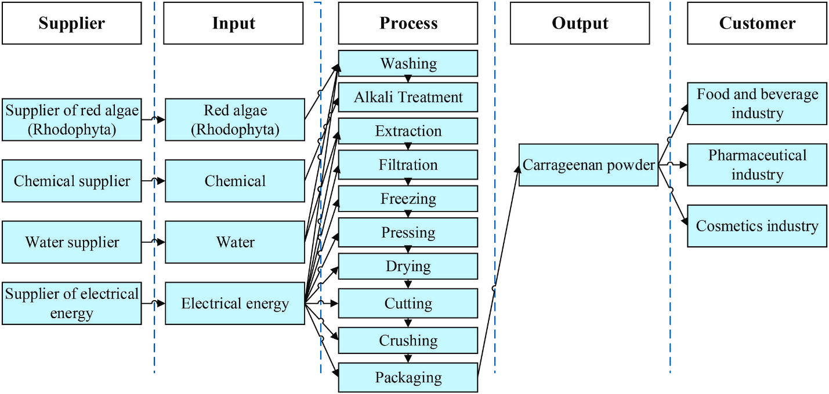

Fig 2**.** SIPOC diagram of carrageenan production (Utama, Abirfatin, 2023).

Previous research conducted on sustainable manufacturing identified three critical sustainability dimensions: economic, social, and environmental. Based on SIPOC diagram the producer was able to deter 14 sustainability indicators for all 3 dimensions (Fig.3).

To determine the value of those indicators the manufacturer utilisedthe **Delphi method.** The panel of experts provided feedback on the indicators and their relevance to sustainable manufacturing. Feedback was based on anonymous questionnaires that were sent to experts. Weighted Average (WA) and Level of Consensus (LC) were calculated for each indicator:

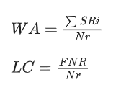

*Sri* - relevance assessment score of the respondent, *FNR* - number of respondents who gave relevant answers, *Nr* symbolizes - total number of respondents (Utama, Abirfatin, 2023).

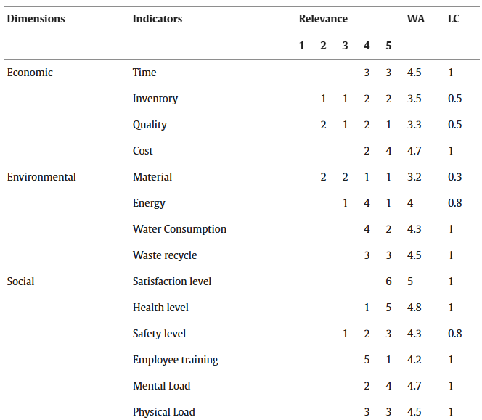

Fig.3. Sustainable manufacturing dimensions and it’s 14 indicators with relevance scores (Utama, Abirfatin, 2023).

**Measure – Traffic Lights to Sustainability: A VSM-MSI Approach**

To Measure economic, environmental and social performance, producer used Manufacturing Sustainability Index (MSI). The index was calculated using a two-step process:

* *Indicator Efficiency Assessment:* This step involved calculating the efficiency of each indicator using specific formulas. The formulas compare resource use to value added, providing a measure of how efficiently resources are utilized for all 14 indicators: time, inventory, quality, cost, material, energy, water consumption, waste recycling, employee satisfaction, health, safety, training, mental load, and physical load (Fig. 4).

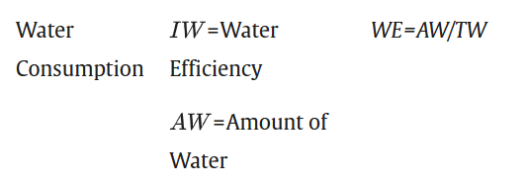

Fig. 4. An example of calculating water consumption indicator. (Utama, Abirfatin, 2023).

* *Weighting and Aggregation:* After determining the efficiency scores for all indicators, each of them was weighted to reflect their relative importance in the overall sustainability assessment. The **Analytical Hierarchy Process (AHP)** was applied to determine these weights, involving pairwise comparisons of the indicators within each dimension (economic, environmental, and social) (Fig. 5). The weighted efficiency scores are then aggregated to calculate the final MSI score.

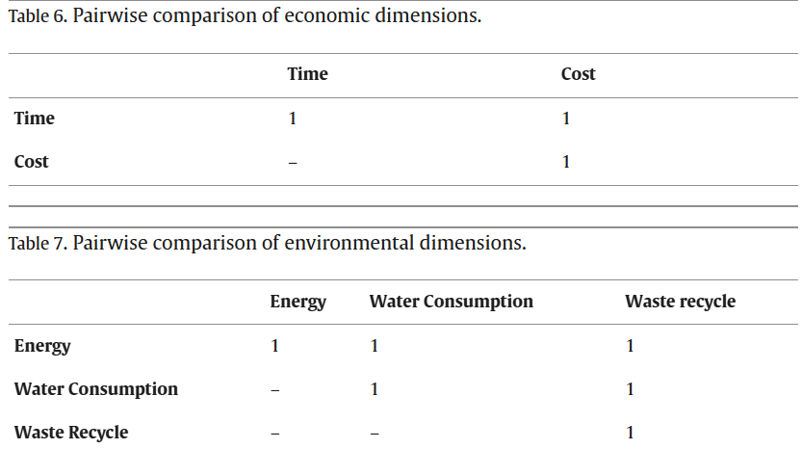

Fig. 5. An example of pairwise comparisons of the indicators within economic and environmental dimensions (Utama, Abirfatin, 2023).

**Value Stream Mapping (VMS)** a visual representation process flow, combined with final MSI score was used to assess company sustainability performance (Fig. 6). Red, yellow, and green lights represent poor, moderate, and excellent performance, allowing them to identify areas that require immediate attention.

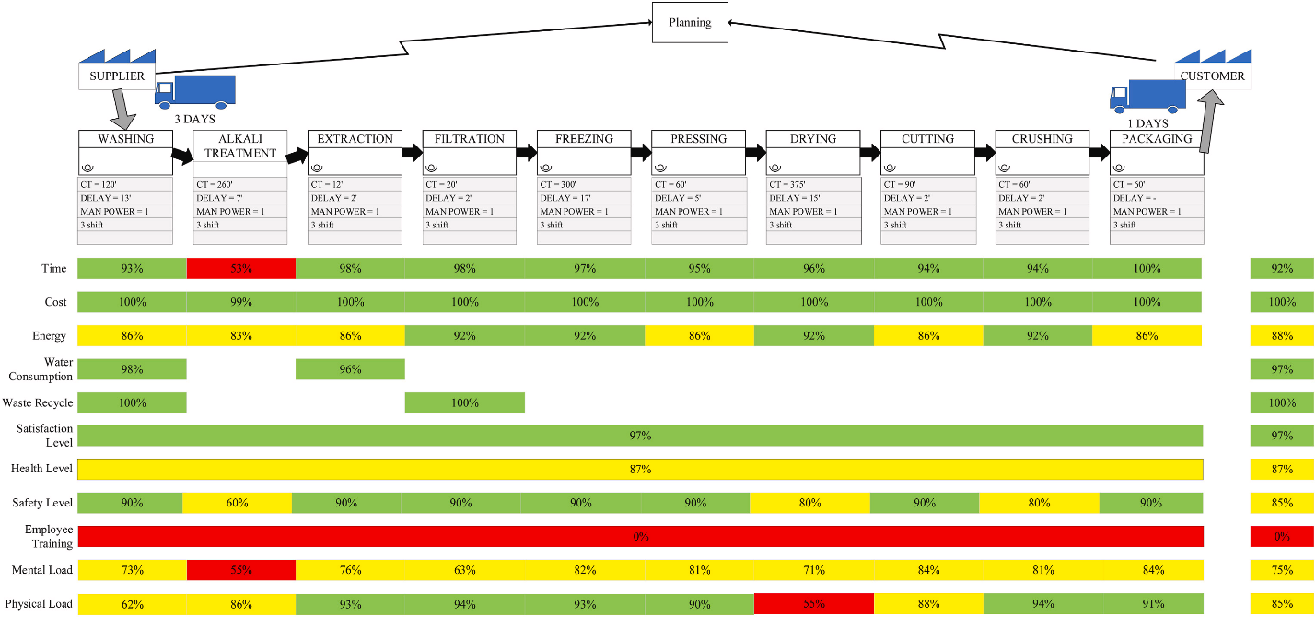

Fig. 6. Value Stream Mapping with the final MSI score (%) of carrageenan production (Utama, Abirfatin, 2023).

**Analyse – VSM: Your Roadmap to Operational Excellence**

The results of a VSM analysis identified five areas requiring improvement in a production process. Four indicators [time spent at the alkali treatment workstation, employee training, mental and physical workload] showed efficiency levels below 60%, indicating a need for immediate action. Additionally, the safety level at the alkali treatment workstation also registered a low efficiency of 60%, highlighting the need for development.

**Improve - Predicting Efficiency: The Future of Sustainable Manufacturing**

The study suggested further use of Value Stream Mapping in the improvement phase and developing strategic solutions. As mentioned before, the study analyzed the efficiency of a production process and identified five areas requiring improvement. By addressing them the researchers projected a future efficiency score of 93.80%, classified as excellent (Fig.7).

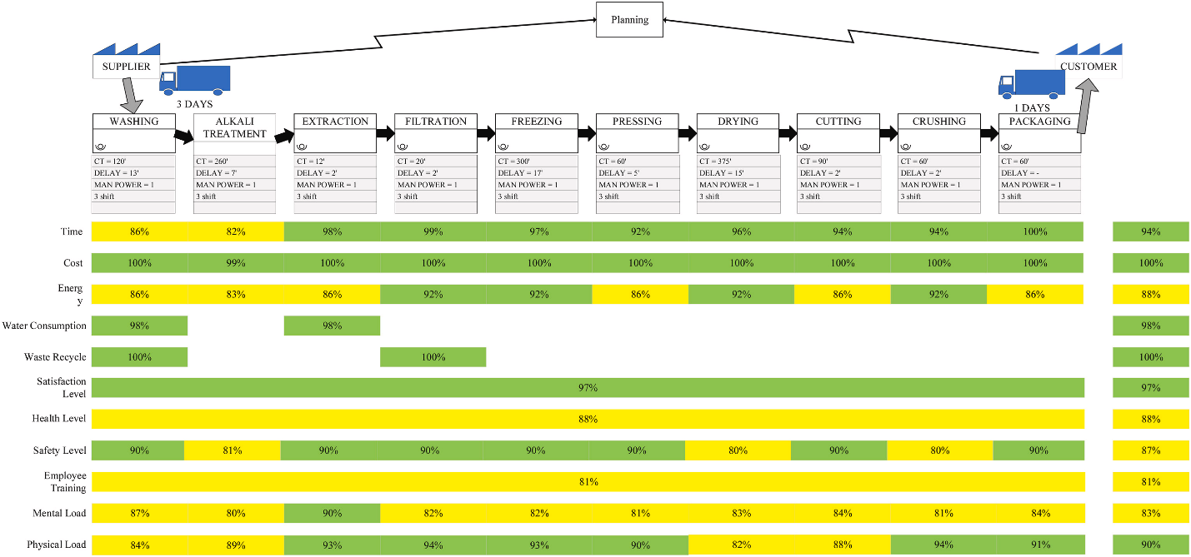

(Fig. 7.) Value Stream Mapping after the Improve stage (Utama, Abirfatin, 2023).

**Control- Check Sheets: A Simple Tool for Big Improvements**

The organization decided on using check sheets to guide employees in preventing failures during the improvement processes. Previous research showed that check sheets were successful in verifying that employee implemented recommended safety measures, such as using appropriate personal protective equipment. The producer concluded that utilizing this tool would effectively improve both operational quality and safety, ultimately leading to a more efficient and sustainable manufacturing environment.

This case study demonstrates the effectiveness of the Lean Six Sigma DMAIC framework in achieving sustainable manufacturing goals. The Indonesian producer successfully applied the framework to their carrageenan production process, resulting in the identification of key areas for improvement across economic, environmental, and social dimensions. This further proves that Lean Six Sigma is versatile methodology and can be applied to various sustainability challenges.

I hope you’ve enjoyed the content. In a subsequent blog post, we will delve deeper into the potential of Lean Six Sigma as a tool for achieving sustainability objectives. An application of DMAIC sub-methodology with quality KPI and 6R in a landscape of ultra-modern manufacturing technologies of Industry 4.0. Please let us know your thoughts. Your input would be greatly appreciated in the comments.

References:

Sushmith, 2023. ‘DMAIC Methodology - The Ultimate Guide Sprintzeal [blog]. 30 September. Available from: <https://www.sprintzeal.com/blog/dmaic-methodology> [Viewed 01 October 2024].

Utama DM, Abirfatin M. 2023.’Sustainable Lean Six-sigma: A new framework for improve sustainable manufacturing performance’, *Cleaner Engineering and Technology,* vol.17, December, art. 100700.